Twin Falls County Historic Preservation Commission
Special Meeting Agenda

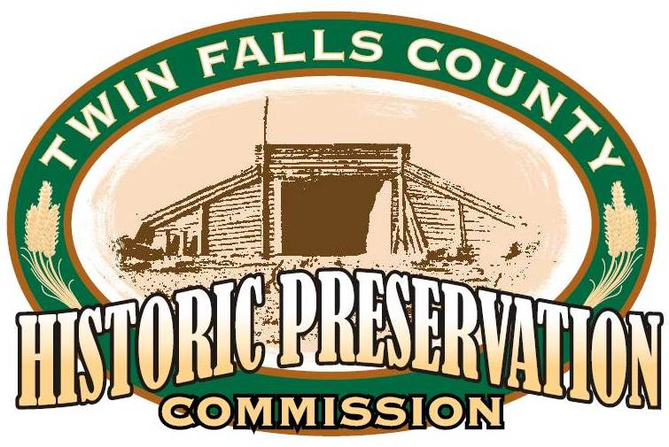

Twin Falls County Historic Preservation Commission
Special Meeting - Conference Room A
630 Addison Ave. West
08 April 2024
1:00 p.m.

1. Confirmation of a quorum

2. Shauna update Murtaugh Bridge mitigation

3. Application Announcement for Historic Preservation Board Member Position

4. Other

5. Field Trip Southern Idaho Solid Waste Operation Facility

6. Adjournment

